User Manual Flexxopomp
A dosing pump for automatically filling a Flexxomat

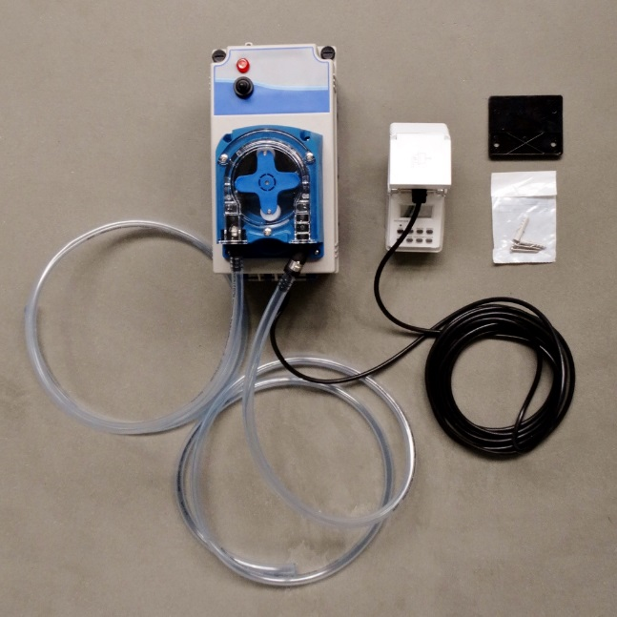

Flexxolutions
Jaartsveldstraat 5
7575 BP Oldenzaal, NL
www.flexxolutions.com

General information

Preservation of the operation manual
The operation manual (including valid documents) must be kept ready for use near the Flexxopomp!

Product liability
For damage to persons, property, the environment and / or operating damage caused by the fact that this operating manual was not, or not fully observed, the company Flexxolutions does not accept any liability. Unauthorized modifications will void the warranty. The company Flexxolutions does not accept any liability nor warranty if, instead of an original spare part as recommended in the operating manual or in the spare parts list, a different spare part is used, and Flexxolutions also does not accept any liability nor warranty if using this non-genuine part leads to personal injury, material damage and / or failure.

Warranty and liability claims for damages to persons, property and the environment are excluded if they are caused by one or more of the following reasons:
- Improper transport, installation, commissioning, operation or maintenance
- Failure to observe the instructions in the operating manual concerning assembly, commissioning, operation and maintenance
- Unauthorized modifications or constructural alterations
- Inadequate monitoring of parts that are subject to wear
- Improperly executed repairs
- Usage not according to the intended purpose
- Impact of foreign objects

Indirect consequential damages – regardless of the type – and natural wear (seals etc.) shall under no circumstances give rise to a liability or a warranty claim.
Corrosion caused by electrochemical reactions (e.g. different ground potential, pH-value of the substrate) or by microbial influences (e.g. bacteria, algae, fungi) does not constitute a defect (reason for complaint).

Spare parts
All spare parts can be delivered by Flexxolutions. To order spare parts, please contact Flexxolutions directly.

Intended use
The Flexxopomp serves exclusively as a dosing pump. The Flexxopomp is suitable for the delivery of diluted disinfectants from a liquid container to the product that needs to be disinfected.

Components of the Flexxopomp

Components of the Flexxopomp
The Flexxopomp consists out of the following parts:

On/off button

Timer

Fluid supply
(from the container)
Fluid supply
(to the mat)

Power plug
230 V

Setting of the Flexxopomp

Follow the instructions below for setting the Flexxopomp:

Photo/Figure | Description
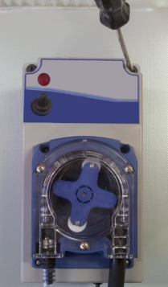 | Open the housing of the Flexxopomp with a screwdriver.
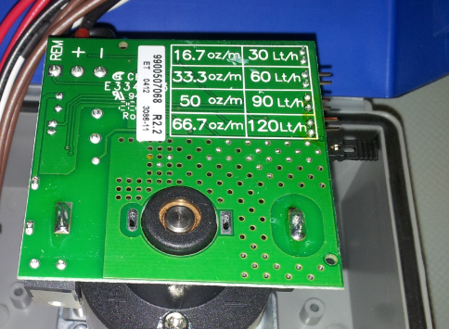 | Set the ‘Jumper’, depending on the desired amount per hour, on 30, 60, 90 or 120 L/hour.  The recommended setting is an amount of 30 L/hour.
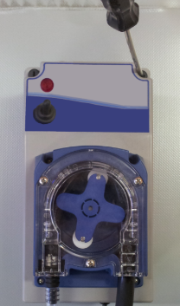 | Close the housing of the Flexxopomp with a screwdriver.
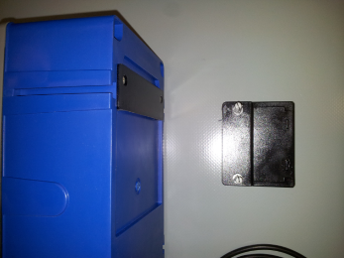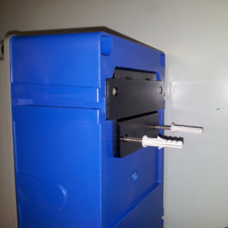 | Attach the black mounting plate to the desired location using the supplied fixing material.  The Flexxopomp can then be attached to this plate.
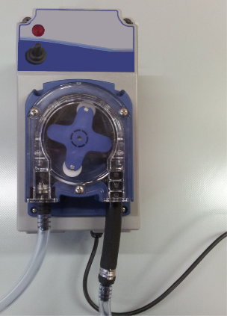 | Attach the hose from the fluid container to the pump. ATTENTION: this is the left plug!!  Attach the hose from the mat to the pump.  ATTENTION: this is the right plug!!

Malfunctions and troubleshooting

What to do when malfunctions occur?
  - In the event of a malfunction, inform the manufacturer of the failure. The manufacturer depends on your experience and feedback in order to be able to implement continuous improvements to the product.
  - In case of fire, warn the local fire brigade.

Troubleshooting
A large proportion of the faults that occur can usually be traced back to a small error or anomaly in the system. Keep the peace and quiet at all times and try to get an overview of the situation. Most failures can be easily detected and rectified quickly by systematic troubleshooting. Please also use the table below.
In case of malfunctions that cannot be easily solved, please contact the manufacturer Flexxolutions.

Malfunction table
Malfunction | Possible cause | Measure
Wrong capacity | The ‘Jumper’ is set wrong | Open the housing and set the ‘Jumper’ on right capacity
No power | Plug not in socket and/or fuse broken | Put plug in socket and/or check the fuse
Leakage in pump | Hose in pump broken | Replace the hose in the pump

- - End of the user manual - -

The description in this operation manual is a general product description. A binding decision about intended use for a certain application can only be made by the Flexxolutions R&D department. The description below does not hold the user free of his own professional behaviour and decision making regarding an actual situation. The used materials in the product may be subject to normal wear. Due to normal wear and alteration the actual situation and specifications may deviate from the start of the lifetime.

© All rights belong to FLEXXOLUTIONS GFS BV. Multiplication, copying or distribution of this document or parts of the documents prohibited except in the situation Flexxolutions give s prior his approval in written form.
In this document drawings and pictures are used which show the standard configuration. The actual situation may deviate from this.

